Terms and Conditions for the Subscription Window
  - Long-term Slots
June 2024
Version published on 13th June 2024

Interpretation
In this Terms and Conditions for the Subscription Window (“TCSW”):
- All references to a clause/section/paragraph, unless specified otherwise, are references to a clause/section/paragraph in this TCSW;
- All capitalized words and expressions used in this TCSW are to be interpreted according to the list of definitions of Chapter 5 of the LNG Access Code (“ACL”), unless specifically defined in this TCSW;
- The layout, heading and (sub)sections are only for the benefit of the reader and are inconsequential as regards to the interpretation of content of this TCSW;
- The description of rules, conditions and provisions only relates to the LNG Services offered via this TCSW;
- All dates and time are referred to as in Belgium local time.

Introduction
Fluxys LNG NV/SA (“Terminal Operator”) has decided to launch a subscription window combined with an Auction Form (“Subscription Window”) for Slots in response to a demonstrated market interest.
In accordance with and as defined in the LNG Access Code, a Slot is an entitlement to berth an LNG Ship at the LNG Terminal in Zeebrugge and to unload, store and regasify its cargo of LNG.
This TCSW defines the relation between Terminal Operator and Participants to the Subscription Window, the requirements for participating to the Subscription Window, as well as the evaluation and allocation rules of offered LNG Services on basis of the binding requests received by Terminal Operator (hereafter referred to as “Binding Requests”).

Terms of the Subscription Window

Opening and Closing time
This Subscription Window will be open from 10th June 2024 at 5pm local time (“Opening Time”) until the 1st July 2024 at 2pm local time (“Closing Time”).
Any Binding Requests received by Terminal Operator after the Closing Time shall automatically be excluded from this Subscription Window.
LNG Services on offer will be allocated by Terminal Operator at the latest on 5th July 2024 at 2pm.

Description of the offered Services
The LNG Services on offer through this Subscription Window are two lots of Slots which can be requested between 2027 and 2044 (included). Each lot consists of 12 Slots per year. For 2027, Slots are available as of April, leading to only 9 slots on offer for that specific year.
In line with the applicable scheduling rules as described in Article 3.1.1 of the ACL, each lot offers thus the possibility to bring each month one cargo of LNG to the LNG Terminal in Zeebrugge.
For each lot, the number of Slots per year is fixed. Participants are however free to choose the start year and end year of the period for which they would like to subscribe such lots. For example, a Participant can choose to request 1 lot for the period 2030 to 2040. A minimum subscription period of one Year is required, except for 2027 where the minimum subscription period is reduced to nine Months and starts on the 1st of April.

Tariff
The applicable Tariff for the Services contracted under this Subscription Window will be the Regulated Tariff as approved by the CREG, which can be found on Fluxys website, plus any applicable premium as defined in section 5.
For information, the Regulated Tariff for a Slot during the month of June 2024 (calculated with the index of May 2024) is 615.032,09 €/Slot
It should be noted that CREG has approved the Regulated Tariffs for LNG Services until 2039 included. Any Binding Request with regards to lots on offer for the period from 1st January 2040 until 31st December 2044 shall remain conditional upon the Regulated Tariff for Slots approved by the CREG not being higher than the currently applicable Regulated Tariff adjusted for indexation. In case this condition is not met, Participant may request Terminal Operator to reduce the number of its allocated Slots in order to offset the increase in Regulated Tariff.

Participating and submitting a Binding Request

Becoming a Terminal User
This Subscription Window is open to any Terminal User who has signed an LNG Services Agreement (“LSA”). To that end, interested parties who have not yet entered into an LSA need to:
- Make a request to receive the LSA by sending a completed Know-Your-Customer Form (“KYC”) to info.lng@fluxys.com;
- The requesting party will receive a signed version of the LSA after Terminal Operator has carried out a positive internal assessment of all information required in the KYC;
- Return to Terminal Operator one duly signed and initialed copy of the LSA.
As from this point, the requesting party is a Terminal User and can become a Participant under this TCSW.

Participating to the Subscription Window
Any Terminal User becomes a Participant under this Subscription Window as from the moment such Terminal User submits, before the Closing Time, a duly completed and signed version of the Service Request Form for Contracting (“SRFC”) to Terminal Operator (see Annex 1).
Please note that only one (1) Affiliate may participate to the Subscription Window. If it appears that two or more Affiliates (intend to) take part in the Subscription Window, Terminal Operator will exclude all concerned Affiliates from this Subscription Window, except the first one having sent a Binding Request.
A Participant may simultaneously submit its Binding Request with its request for an LNG Services Agreement, but such Binding Request will only be considered as a valid Binding Request if a version of the Agreement signed by the Terminal User authorized representatives is returned to Terminal Operator before the Closing Time of the Subscription Window.

Submitting a Binding Request
During the Subscription Window, a Participant can submit a Binding Request for contracting lot(s) of Slots by submitting a duly completed and signed SRFC, as available in Annex 1. The request will specify:
- The number of lots the Participant wishes to subscribe, i.e. 1 or 2 lot(s) and
- The start year and end year of the requested lot(s)
Participants also have the possibility (but not the obligation) to specify in their SRFC
- The Minimum Request, i.e. the minimal number of lots below which the Participant is not interested in subscribing the Services;
- The premium (in €/Slot) the Participant is ready to pay on top of the Regulated Tariff for each Slot. Such premium will only be used in case a one-step auction is needed to perform the allocation (see 5.1). In this case, the resulting premium will apply to every Slot of the allocated lot. In all other cases, this premium will be discarded.
By default, a value of “0” will be considered for these two optional parameters.
The Binding Request containing the SRFC shall be sent by email to info.lng@fluxys.com. Participant may change its Binding Request by sending an adjusted SRFC that will overwrite and substitute the previous SRFC. Once the Closing Time is reached, no (new) Binding Request can be submitted and the last Binding Request accepted by Terminal Operator will be considered.

Evaluation of the Binding Request
Terminal Operator shall evaluate whether the SRFC submitted by the Participant is duly completed and as the case may be shall:
- accept the SRFC to be a Binding Request; or
- in case of missing information, require from the Participant an adapted SRFC replacing the previous SRFC; any Binding Request received by Terminal Operator after the above-mentioned Closing Time shall automatically be excluded from this Subscription Window; or
- when it has reasonable grounds to suspect that accepting the SRFC could pose a significant risk to the security of supply of Belgium and/or of the European Union, refer the submitted SRFC to the Government Authority competent for security of supply (the “Competent Authority”*) for a binding decision on whether accepting such SRFC could pose a significant risk to the security of supply interests of Belgium and/or of the European Union; should the Competent Authority come to the conclusion that an acceptance of the SRFC could pose a significant risk to the security of supply interests of Belgium and/or of the European Union, Terminal Operator shall then refuse the SRFC as a Binding Request; absent such a decision of the Competent Authority within 3 business days of the referral to this authority of the submitted SRFC, Terminal Operator shall accept the SRFC to be a Binding Request.
Terminal Operator shall in no way be responsible or held liable for any damages suffered by the Participant in the event Terminal Operator does not accept the Binding Request of the Participant because of either (i) an incomplete SRFC or (ii) a decision of the Competent Authority that accepting the Binding Request could pose a significant risk to the security of supply interests of Belgium and/or of the European Union.
* Federal Minister in charge of Energy, upon advice of the DG Energy of the Federal Public Service Economic Affairs

Allocation Process

Allocation Rules
In line with Article 2.2 of the ACL, the two lots on offer will be allocated as follows:
- If the total demand for lots is equal to or lower than the offered Services, each Participant will be allocated its requested quantity;
- If the total demand for lots is higher than the offered Services, the following criteria will be sequentially applied:
  - Priority will be given to Binding Requests with the longest duration. Given the earliest start date of the offered lots is April 2027, 2027 will only count for 9 months when computing this duration;
  - If several Participants have the same duration, a pro-rata allocation of the offered lot(s) will be performed amongst them. When computing the pro-rata quantities, decimal numbers will be rounded to the nearest integer number. If the application of the pro-rata allocation results in a number of lot(s) allocated to a Participant which is less than its Minimum Request, no lot(s) will be allocated to this Participant.
For the sake of clarity, pro-rata quantities for each Participant are computed as “requested number of lots x (number of offered lots / total requested number of lots);
  - If the pro-rata allocation leads to a partial allocation or no allocation at all, priority will be given to Binding Requests with the earliest start year;
  - If the previously mentioned criteria do not result in a complete allocation of the Services, a one-step auction will be used as a final differentiating factor. Participants with the highest pro-rata quantities (after rounding) who have not been allocated capacity based on the previous criteria will be included in this auction.
If a lot has already been allocated previously, the remaining lot will be allocated to the Participant with the highest premium on Slot price (see 4.3). If both lots are still available, the lots will be allocated to the two Participants with the highest premia on Slot price.
If one or several lot(s) cannot be allocated because two or more Participants indicated the same premium on Slot price, Terminal Operator will contact these Participants on 2nd July 2024 at 2pm and request them to send an updated Binding Request containing their best and final premium on Slot price within the next 24 hours. Priority for the allocation will then be given to the highest best and final premium on Slot price.
Note that if both lots are allocated through this one-step auction, the price of the Services will be equal to the sum of the Regulated Tariff and the lowest premium which led to allocation of Services.
In case capacity is still available after this Subscription Window, Terminal Operator will launch an Auction Window to sell the remaining Services within 10 weeks following the end of the Subscription Window.

Allocation Results
Terminal Operator will confirm the results of the allocation procedure to the Participants on 5th July 2024 at 2pm at the latest.

Cancellation by Terminal Operator
Terminal Operator may at any time prior, during, or after the Subscription Window cancel the Subscription Window without any notice or indemnity, in particular but without limitation, in the event the offered LNG Services cannot be fully allocated.

Performance of the Offered Services
The submission of a Binding Request constitutes a legally binding offer on the part of the Participant which, for the lot(s) he has been allocated pursuant to and in accordance with this TCSW, shall be a legally binding commitment on Participant’s part, governed by the LNG Services Agreement and the ACL.
In case Participant has been allocated capacity, Participant shall pay the applicable Tariff for the allocated services.
Terminal Operator shall only be obliged to perform the Slots during the Service Duration of the Service Confirmation if Participant has duly completed the Service Confirmation for Contracting (as defined in the LNG Services Agreement).

Other provisions

Representation and Warranties by the Participant
In addition to article 9 of attachment B of the LSA, the Participant warrants that:
- It determines independently its participation in the Subscription Window, without any contact with a competitor as to the frequency and the level of its Binding Request.
- The Participant is aware of the prohibitions set by article 101 and 102 of the Treaty on the functioning of the European Union and article IV.1 and IV.2 of the Belgian Code de droit économique / Wetboek van economisch recht.
- It has not already sold, even on a conditional basis, the capacity which is being awarded through the Subscription Window;
- The Participant will only submit a Binding Request for capacity pursuant to a bona fide estimate of Participant’s actual needs. The Participant will not engage in hoarding behavior.

Languages
All communications pertaining to the Subscription Window shall be in the English language only. The convention used for writing numbers in this TCSW is that the space is used to indicate multiples of a thousand and the comma as the decimal point.

Governing Law and disputes
For the avoidance of doubt, Clause 6 of the LNG Services Agreement is applicable.

Annex 1
Service Request Form for Contracting

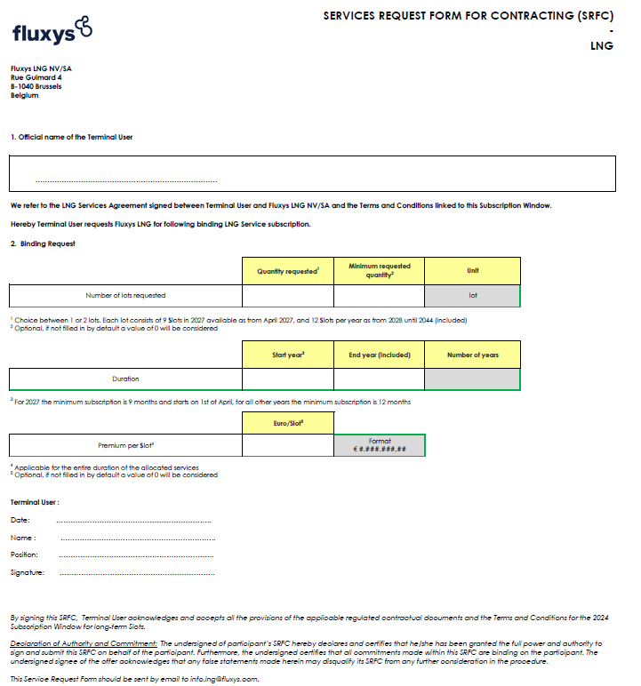

See also §4.1 of LNG Terminalling Program for a description of a Slot
“0,5” will be rounded up to “1”
If 1 lot has already been allocated through the longest duration criteria, the “number of offered lots” will be equal to 1.

